# eBilling and Invoice System Data Dictionary

## Table : product_master

**Owner:** dbo

**Destination DB name:** ebill

**Number of columns:** 5

**Number of indexes:** 2

**Number of foreign keys:** 0

**Extended attributes:**

**OnFileGroup** PRIMARY

**Clustered PK** Yes

|  |  |  |  |
| --- | --- | --- | --- |
| **Columns** | **Data type** | **Allow NULLs** | **Value/range** |
| **Sno** | int | Not allowed |  |
| **ProdType** | nvarchar(60) | Not allowed |  |
| **ProdSubType** | nvarchar(60) | Not allowed |  |
| **Rate** | int | Not allowed |  |
| **isactive** | nvarchar(30) | Not allowed |  |

|  |  |  |
| --- | --- | --- |
| **Indexes** | **Type** | **Columns** |
| **PK_ProductMaster_sno** | clustered, unique, primary key located on PRIMARY | sno |

## Table : bill

**Owner:** dbo

**Destination DB name:** ebill

**Number of columns:** 15

**Number of indexes:** 3

**Number of foreign keys:** 0

**Extended attributes:**

**OnFileGroup** PRIMARY

**Clustered PK** Yes

|  |  |  |  |
| --- | --- | --- | --- |
| **Columns** | **Data type** | **Allow NULLs** | **Value/range** |
| **sno** | int | Not allowed |  |
| **invoiceno** | nvarchar(60) | Not allowed |  |
| **canme** | nvarchar(60) | Not allowed |  |
| **Invoice_date** | datetime | Not allowed |  |
| **location** | nvarchar(60) | Not allowed |  |
| **chalan_no** | int | Not allowed |  |
| **customer_name** | nvarchar(100) | Not allowed |  |
| **Customer_address1** | nvarchar(100) | Not allowed |  |
| **Customer_address2** | nvarchar(100) | Allowed |  |
| **Total_amt** | int | Not allowed |  |
| **discount** | int | Not allowed |  |
| **Amt_words** | nvarchar(100) | Not allowed |  |
| **Paid_type** | nvarchar(60) | Not allowed |  |
| **Cheque_no** | nvarchar(60) | Allowed |  |
| **Entry_date** | datetime | Not allowed |  |

|  |  |  |
| --- | --- | --- |
| **Indexes** | **Type** | **Columns** |
| **PK_Bill_SNO** | clustered, unique, primary key located on PRIMARY | sno |
| **IX_bill_cname** | nonclustered located on PRIMARY | cname |
| **IX_bill_invoiceno** | nonclustered, unique located on PRIMARY | invoiceno |

## Table : bill_details

**Owner:** dbo

**Destination DB name:** ebill

**Number of columns:** 6

**Number of indexes:** 3

**Number of foreign keys:** 2

**Extended attributes:**

**OnFileGroup** PRIMARY

**Clustered PK** Yes

|  |  |  |  |
| --- | --- | --- | --- |
| **Columns** | **Data type** | **Allow NULLs** | **Value/range** |
| **sno** | int | Not allowed |  |
| **Bill_sno** | int | Not allowed |  |
| **Prod_sno** | nvarchar(60) | Not allowed |  |
| **qty** | datetime | Not allowed |  |
| **rate** | nvarchar(60) | Not allowed |  |
| **amt** | int | Not allowed |  |

|  |  |  |
| --- | --- | --- |
| **Indexes** | **Type** | **Columns** |
| **PK_Bill_details_SNO** | clustered, unique, primary key located on PRIMARY | sno |
| **IX_bill_details_bill_sno** | nonclustered located on PRIMARY | Bill_sno |
| **IX_bill_deatils_prod_sno** | nonclustered, unique located on PRIMARY | Prod_sno |

## Table : Company_master

**Owner:** dbo

**Destination DB name:** ebill

**Number of columns:** 7

**Number of indexes:** 2

**Number of foreign keys:** 0

**Extended attributes:**

**OnFileGroup** PRIMARY

**Clustered PK** Yes

|  |  |  |  |
| --- | --- | --- | --- |
| **Columns** | **Data type** | **Allow NULLs** | **Value/range** |
| **Company_name** | nvarchar(60) | Not allowed |  |
| **Address1** | nvarchar(100) | Not allowed |  |
| **Address2** | nvarchar(100) | Allowed |  |
| **city** | nvarchar(60) | Not allowed |  |
| **pin** | int | Not allowed |  |
| **telephone** | nvarchar(60) | Not allowed |  |
| **vatno** | nvarchar(60) | Not allowed |  |

|  |  |  |
| --- | --- | --- |
| **Indexes** | **Type** | **Columns** |
| **PK_comapny_master_company_name** | clustered, unique, primary key located on PRIMARY | Comapnay_name |
| **IX_ comapny_master_pin** | nonclustered located on PRIMARY | pin |

## Table : user_master

**Owner:** dbo

**Destination DB name:** ebill

**Number of columns:** 3

**Number of indexes:** 2

**Number of foreign keys:** 0

**Extended attributes:**

**OnFileGroup** PRIMARY

**Clustered PK** Yes

|  |  |  |  |
| --- | --- | --- | --- |
| **Columns** | **Data type** | **Allow NULLs** | **Value/range** |
| **user_name** | nvarchar(60) | Not allowed |  |
| **User_password** | nvarchar(60) | Not allowed |  |
| **User_type** | nvarchar(60) | Allowed |  |

|  |  |  |
| --- | --- | --- |
| **Indexes** | **Type** | **Columns** |
| **PK_user_master_user_name** | clustered, unique, primary key located on PRIMARY | user_name |
| **IX_ user_master_user_type** | nonclustered located on PRIMARY | User_type |

# eBilling and Invoice System – Data Schema ER Diagram

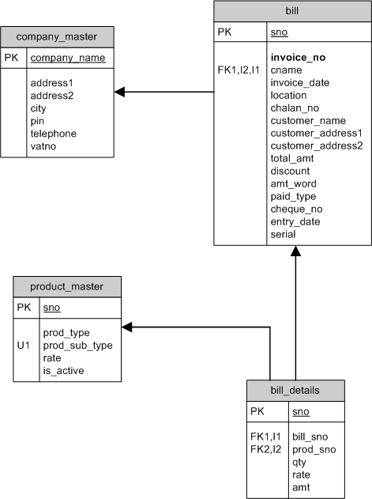

# eBilling and Invoice System DFD (Data Flow Diagram)

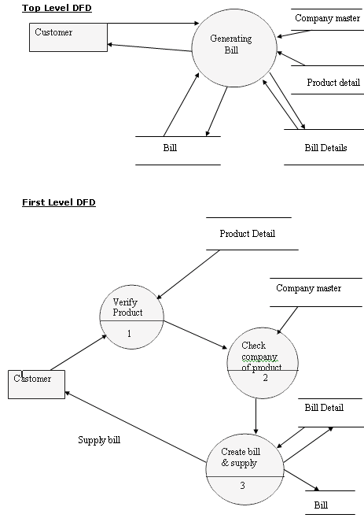

# Form Design and Coding

### FrmSplash

(Module to show startup screen)

